INTEGRATIVE COURSE IN PSYCHOLOGY (ICOPSYCH)

ANALYSIS ON THE RESULT OF POST-TEST EXAMINATION IN PSYCHOLOGICAL ASSESSMENT
MAY 2, 2025

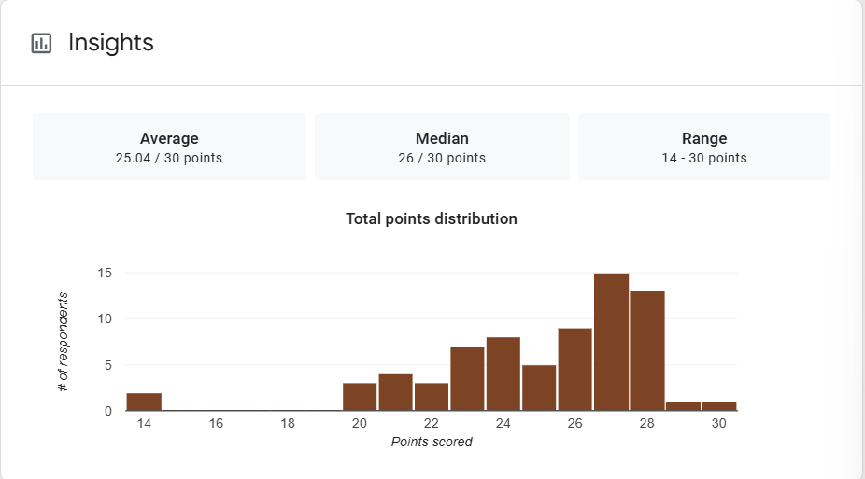

1. Mean Score: The mean or average score is 25.04, which corresponds to 83.5%. This indicates that students performed quite well overall. This level of performance reflects a strong understanding of the material by the majority of the class.

2. Median Score: The median, the middle score in the distribution, is 26 points (86.7%). Since the median is slightly higher than the mean, this suggests a mildly left-skewed (negatively skewed) distribution. This pattern typically indicates that most students did well, but there may be a small subset who struggled modestly.

3. Range: This means the lowest score was 14 (46.7%), and the highest was a perfect score of 30 (100%). Despite the presence of a lower-end score, the range is relatively moderate compared to the overall scale, suggesting a reasonable spread without extreme disparity.

Interpretation Summary:
-The test results reveal a high overall level of student achievement, with an average score of 25.04 (83.5%) and a median of 26 (86.7%), indicating that most students scored in the top range.
-The slightly higher median than mean points to a mild left-skewed distribution, suggesting a few lower scores slightly lowered the average.
-With a range of 14–30, the data shows moderate variability, but nothing extreme. Overall, the class appears to have a solid grasp of the content, with only a small number of students who might benefit from targeted support.

RATIONALIZATION:

DIFFICULT QUESTIONS:

